НАЦІОНАЛЬНИЙ ТЕХНІЧНИЙ УНІВЕРСИТЕТ УКРАЇНИ

“КИЇВСЬКИЙ ПОЛІТЕХНІЧНИЙ ІНСТИТУТ ІМЕНІ ІГОРЯ СІКОРСЬКОГО”

Факультет інформатики та обчислювальної техніки

Кафедра обчислювальної техніки

Лабораторна робота №7

з дисципліни

“Програмування мобільних систем”

Виконав:

студент групи IВ-81

ЗК 8106

Бухтій О.В.

Київ 2021

1. **Визначення варіанту:**

Я не мав доступу до Coredata

Посилання на репозиторій: [https://github.com/KekemonBS/PMS/tree/main/LAB_](https://github.com/KekemonBS/PMS/tree/main/LAB_4)8

1. **Виконання:**

Скріншоти:

 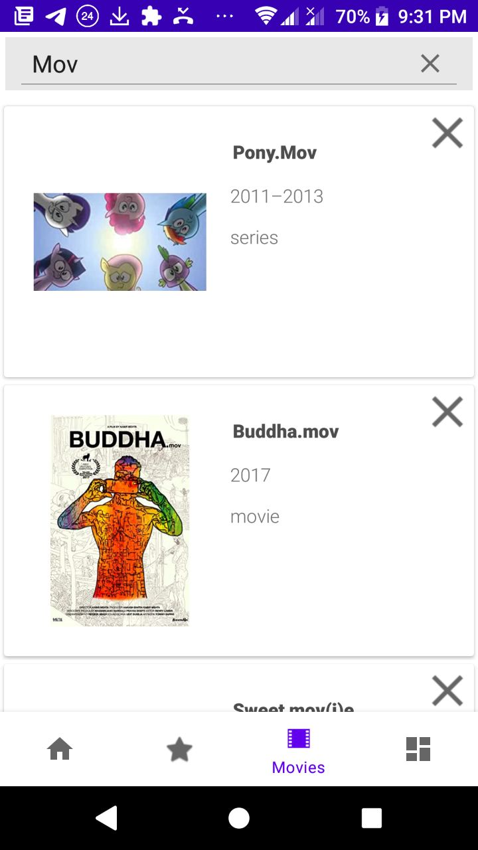

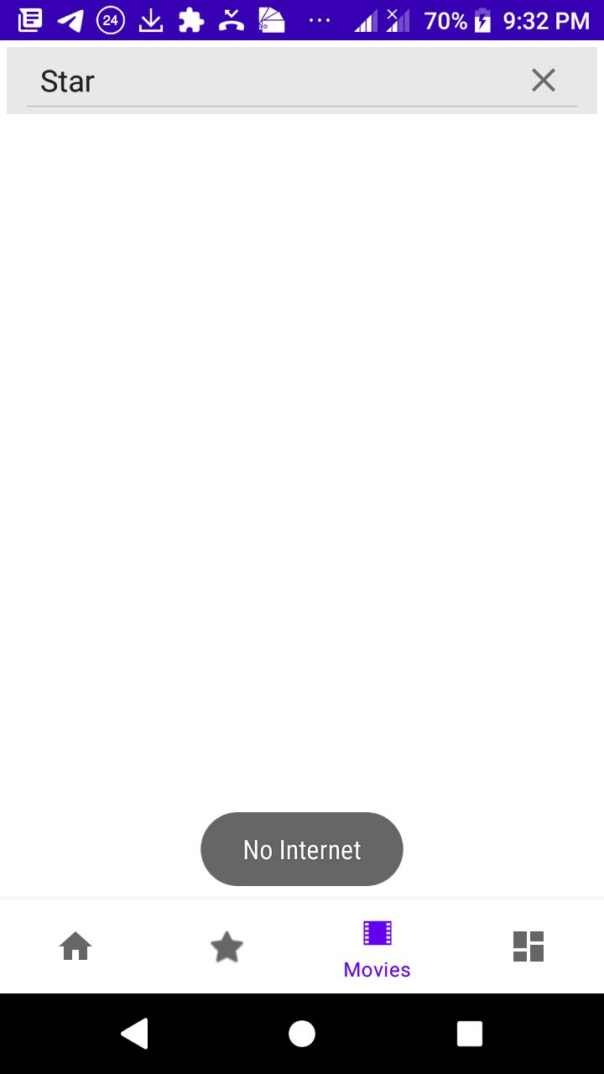 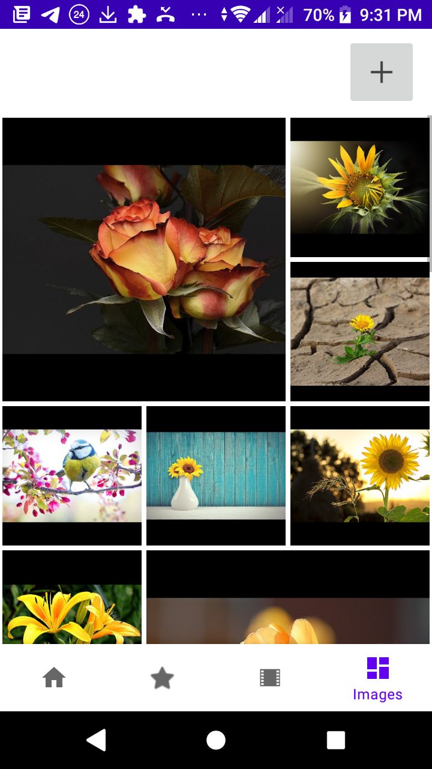

 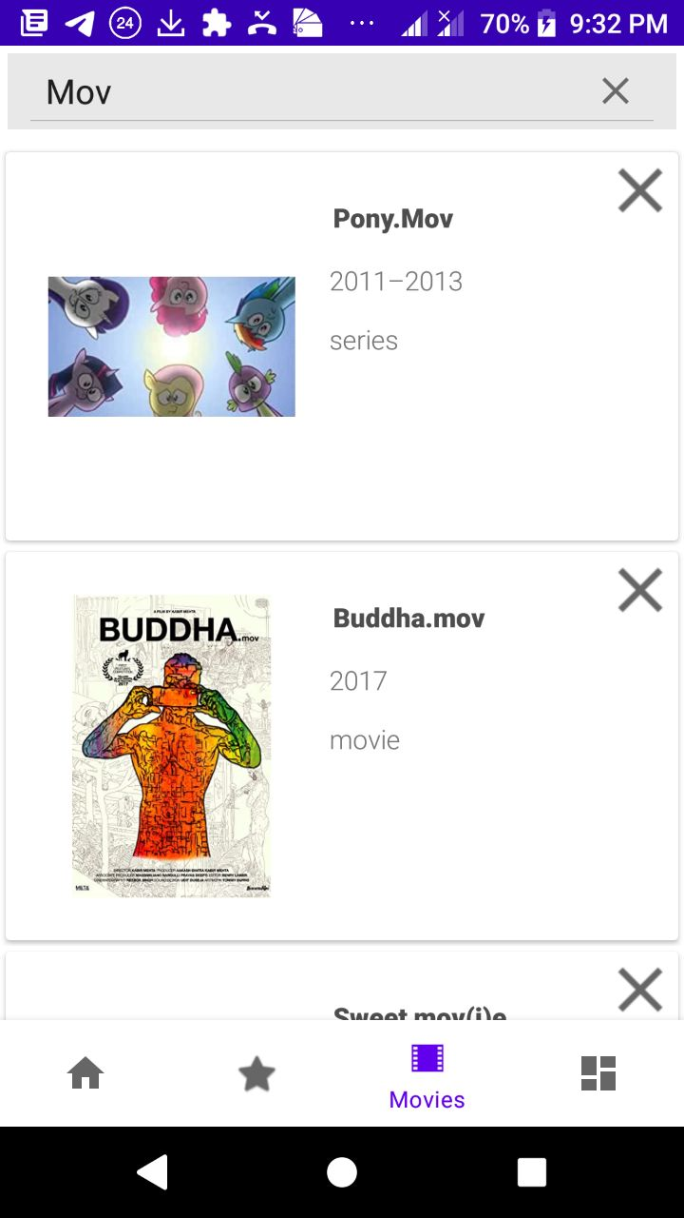

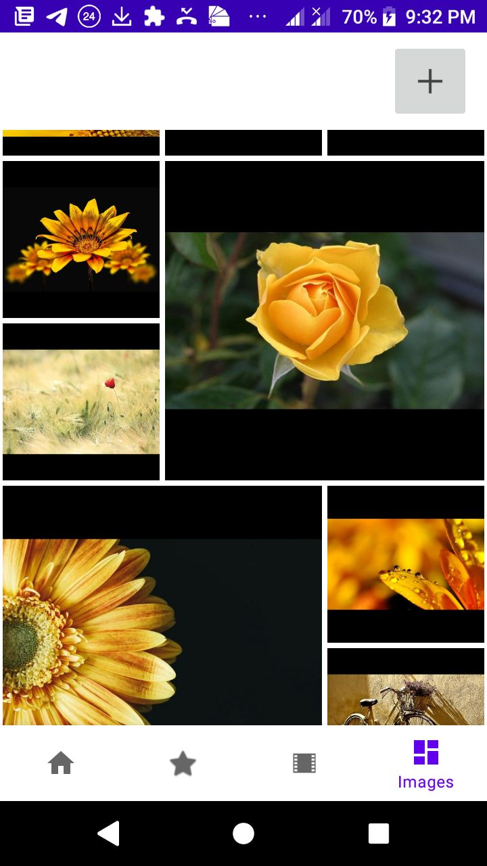 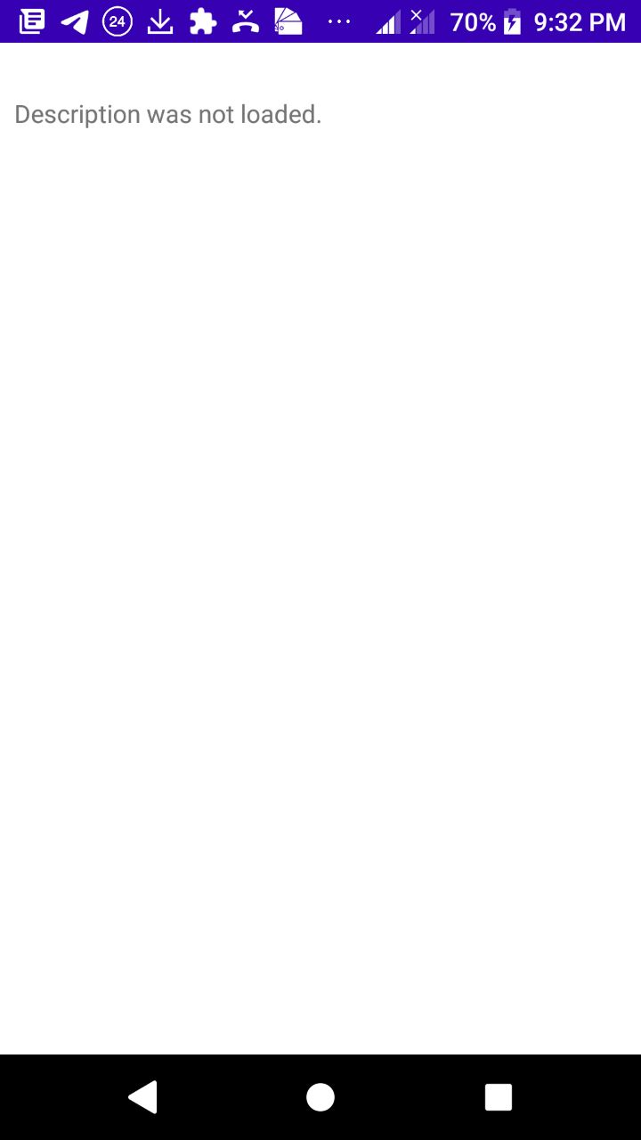

1. **Лістинг коду (основні що були створені/ змінені):**

**---GalleryAdapter.java---**

package ua.kpi.comsys.iv8106.adapters;

import android.view.LayoutInflater;

import android.view.View;

import android.view.ViewGroup;

import android.widget.ImageView;

import android.widget.ProgressBar;

import androidx.annotation.NonNull;

import androidx.fragment.app.Fragment;

import androidx.recyclerview.widget.RecyclerView;

import com.squareup.picasso.Callback;

import com.squareup.picasso.Picasso;

import java.util.ArrayList;

import ua.kpi.comsys.iv8106.R;

import ua.kpi.comsys.iv8106.model.ImageItem;

public class GalleryAdapter extends RecyclerView.Adapter<GalleryAdapter.GalleryViewHolder> {

private final Fragment fragment;

private final ArrayList<ImageItem> images;

public GalleryAdapter(Fragment fragment, ArrayList<ImageItem> images) {

this.fragment = fragment;

this.images = images;

}

public class GalleryViewHolder extends RecyclerView.ViewHolder {

private ImageView iw;

private ProgressBar spinnerImg;

public GalleryViewHolder(@NonNull View itemView) {

super(itemView);

this.iw = (ImageView) itemView.findViewById(R.id.image);

this.spinnerImg = (ProgressBar)itemView.findViewById(R.id.progressBarImg);

}

}

@NonNull

@Override

public GalleryAdapter.GalleryViewHolder onCreateViewHolder(@NonNull ViewGroup parent, int viewType) {

LayoutInflater inflater = LayoutInflater.from(parent.getContext());

View view = inflater.inflate(R.layout.image, parent, false);

return new GalleryAdapter.GalleryViewHolder(view);

}

//-------------------------------------------------------------------------------------------------------------

@Override

public void onBindViewHolder(@NonNull GalleryAdapter.GalleryViewHolder holder, int position) {

//holder.itemView.getLayoutParams().height = 650;

//holder.iw.setImageURI(images.get(position));

holder.spinnerImg.setVisibility(ProgressBar.VISIBLE);

if (images.get(position).getBitmap() == null) {

Picasso.get()

.load(images.get(position).getWebformatURL())/*.placeholder()*/

.into(holder.iw, new Callback() {

@Override

public void onSuccess() {

holder.spinnerImg.setVisibility(ProgressBar.INVISIBLE);

}

@Override

public void onError(Exception e) {

}

});

} else {

holder.iw.setImageBitmap(images.get(position).getBitmap());

holder.spinnerImg.setVisibility(ProgressBar.INVISIBLE);

}

}

//-------------------------------------------------------------------------------------------------------------

@Override

public int getItemCount() {

return images.size();

}

}

**---MoviesAdapter.java---**

package ua.kpi.comsys.iv8106.adapters;

import android.content.Intent;

import android.view.LayoutInflater;

import android.view.MotionEvent;

import android.view.View;

import android.view.ViewGroup;

import android.widget.ImageView;

import android.widget.TextView;

import android.widget.Toast;

import androidx.annotation.NonNull;

import androidx.fragment.app.Fragment;

import androidx.recyclerview.widget.RecyclerView;

import com.squareup.picasso.Picasso;

import java.util.ArrayList;

import ua.kpi.comsys.iv8106.R;

import ua.kpi.comsys.iv8106.model.MovieItem;

import ua.kpi.comsys.iv8106.secondary_activities.MovieDetailsActivity;

public class MoviesAdapter extends RecyclerView.Adapter<MoviesAdapter.MovieViewHolder> {

private final Fragment context;

private final ArrayList<MovieItem> movies;

private final ArrayList<String> maintitle;

public MoviesAdapter(Fragment context, ArrayList<MovieItem> movies, ArrayList<String> maintitle) {

this.context=context;

this.movies=movies;

this.maintitle = maintitle;

}

public class MovieViewHolder extends RecyclerView.ViewHolder {

private ImageView image;

private TextView titleText;

private TextView yearText;

private TextView typeText;

private ImageView deleteButton;

public MovieViewHolder(View view) {

super(view);

// Define click listener for the ViewHolder's View

this.image = (ImageView) view.findViewById(R.id.image);

this.titleText = (TextView) view.findViewById(R.id.title);

this.yearText = (TextView) view.findViewById(R.id.year);

this.typeText = (TextView) view.findViewById(R.id.type);

this.deleteButton = (ImageView) view.findViewById(R.id.deleteButton);

}

}

// Create new views (invoked by the layout manager)

@Override

public MovieViewHolder onCreateViewHolder(ViewGroup parent, int viewType) {

// Create a new view, which defines the UI of the list item

LayoutInflater inflater = LayoutInflater.from(parent.getContext());

View view = inflater.inflate(R.layout.movie, parent, false);

return new MovieViewHolder(view);

}

@Override

public void onBindViewHolder(@NonNull MovieViewHolder holder, int position) {

// int drawableResourceId = context.getResources().getIdentifier(

// movies.get(position).getPoster().toLowerCase().replace(".jpg", ""),

// "drawable", context.getContext().getPackageName());

Picasso.get().load(movies.get(position).getPoster()).into(holder.image);

if (!movies.get(position).isVisible()) {

holder.itemView.setVisibility(View.INVISIBLE);

holder.itemView.getLayoutParams().height = 0;

} else {

holder.itemView.setVisibility(View.VISIBLE);

//holder.itemView.getLayoutParams().height = 650;

}

holder.titleText.setText(maintitle.get(position));

holder.yearText.setText(movies.get(position).getYear());

holder.typeText.setText(movies.get(position).getType());

// if (drawableResourceId != 0) {

// holder.image.setImageResource(drawableResourceId);

// } else {

// holder.image.setImageResource(R.drawable.ic_action_cancel);

// }

holder.deleteButton.setOnTouchListener(new View.OnTouchListener() {

@Override

public boolean onTouch(View v, MotionEvent event) {

removeItem(holder.getAdapterPosition());

return true;

}

});

holder.itemView.setOnClickListener(new View.OnClickListener() {

@Override

public void onClick(View v) {

Intent intent = new Intent(context.getContext(), MovieDetailsActivity.class);

if ((!movies.get(position).getImdbId().equals(null)) &&

(!movies.get(position).getImdbId().equals("noid"))) {

intent.putExtra("id", movies.get(position).getImdbId());

context.startActivity(intent);

} else {

System.out.println(movies.get(position).getImdbId());

Toast toast = Toast.makeText(context.getContext(), "No ID", Toast.LENGTH_SHORT);

toast.show();

}

}

});

}

@Override

public int getItemCount() {

return movies.size();

}

public void removeItem(int position) {

if (position == -1)

return;

this.movies.remove(position);

this.maintitle.remove(position);

notifyDataSetChanged();

}

}

**---GalleryFragment.java---**

package ua.kpi.comsys.iv8106.ui.gallery;

import android.app.Activity;

import android.content.ContentValues;

import android.content.Intent;

import android.graphics.Bitmap;

import android.net.Uri;

import android.os.Bundle;

import android.provider.MediaStore;

import android.view.LayoutInflater;

import android.view.View;

import android.view.ViewGroup;

import android.widget.ImageButton;

import android.widget.ProgressBar;

import androidx.annotation.NonNull;

import androidx.annotation.Nullable;

import androidx.fragment.app.Fragment;

import androidx.recyclerview.widget.RecyclerView;

import com.arasthel.spannedgridlayoutmanager.SpanSize;

import com.arasthel.spannedgridlayoutmanager.SpannedGridLayoutManager;

import com.google.gson.Gson;

import com.google.gson.JsonObject;

import com.google.gson.reflect.TypeToken;

import java.io.IOException;

import java.lang.reflect.Type;

import java.util.ArrayList;

import java.util.LinkedList;

import java.util.Queue;

import kotlin.jvm.functions.Function1;

import ua.kpi.comsys.iv8106.R;

import ua.kpi.comsys.iv8106.adapters.GalleryAdapter;

import ua.kpi.comsys.iv8106.model.ImageItem;

import ua.kpi.comsys.iv8106.tools.Requester;

import ua.kpi.comsys.iv8106.tools.database.Databaser;

public class GalleryFragment extends Fragment {

private int RESULT_LOAD_IMG = 1;

private static String response;

//public ArrayList<Bitmap> images = new ArrayList<>();

Type listOfImagesItemsType = new TypeToken<ArrayList<ImageItem>>() {}.getType();

ArrayList<ImageItem> images = new ArrayList<>();

public GalleryAdapter adapter_gallery = new GalleryAdapter(this, images);

@Nullable

@Override

public View onCreateView(@NonNull LayoutInflater inflater,

@Nullable ViewGroup container,

@Nullable Bundle savedInstanceState) {

this.setRetainInstance(true);

View view = inflater.inflate(R.layout.fragment_gallery, container, false);

RecyclerView recycle = view.findViewById(R.id.galleryRecyclerView);

recycle.setNestedScrollingEnabled(false);

SpannedGridLayoutManager spannedGridLayoutManager = new SpannedGridLayoutManager(

SpannedGridLayoutManager.Orientation.VERTICAL, 3);

spannedGridLayoutManager.setItemOrderIsStable(false);

spannedGridLayoutManager.setSpanSizeLookup(new SpannedGridLayoutManager.SpanSizeLookup(new Function1<Integer, SpanSize>(){

@Override public SpanSize invoke(Integer position) {

if (position % 9 == 0) {

return new SpanSize(2, 2);

} else if ((position - 7) % 9 == 0) {

return new SpanSize(2, 2);

} else {

return new SpanSize(1, 1);

}

}

}));

ImageButton addButton = view.findViewById(R.id.moreImageButton);

ProgressBar spinner = (ProgressBar)view.findViewById(R.id.progressBar);

spinner.setVisibility(ProgressBar.VISIBLE);

recycle.setLayoutManager(spannedGridLayoutManager);

recycle.setAdapter(adapter_gallery);

//----------------------------------------------------------------------------------

//Perform request in separate thread

new Thread(new Runnable() {

@Override

public void run() {

Databaser db = new Databaser(getContext(), "lists", null, 1);

String request = "yellow+flowers";

if (db.queryTable("imageList", request, "query") == null) {

String formattedUrlString = "https://pixabay.com/api/?key=%s&q=%s&image_type=photo&per_page=%s";

String apiKey = "19193969-87191e5db266905fe8936d565";

String count = "27";

Queue<String> queue = new LinkedList<>();

Requester req = new Requester(queue, formattedUrlString, apiKey, request, count);

Thread th1 = new Thread(req, "images");

th1.start();

try {

th1.join();

setJSONResponse(queue.remove());

} catch (InterruptedException e) {

e.printStackTrace();

}

System.out.println(response);

if (response != null) {

//-------------------------

ContentValues row = new ContentValues();

row.put("query", request);

row.put("json", response);

db.apppendToTable("imageList", request, "query", row);

//-------------------------

}

} else {

response = db.queryTable("imageList", request, "query");

}

updateImagesList(response);

spinner.setVisibility(ProgressBar.INVISIBLE);

}

}).start();

//----------------------------------------------------------------------------------

addButton.setOnClickListener(new View.OnClickListener() {

public void onClick(View v) {

Intent photoPickerIntent = new Intent(Intent.ACTION_PICK);

photoPickerIntent.setType("image/*");

startActivityForResult(photoPickerIntent, RESULT_LOAD_IMG);

}

});

System.out.println("HERE1");

return view;

}

private void updateImagesList(String response) {

Gson gson = new Gson();

if (response != null &&

gson.fromJson(response, JsonObject.class).has("hits")) {

JsonObject gsontmp = gson.fromJson(response, JsonObject.class);

images.clear();

images.addAll(gson.fromJson(gsontmp.get("hits"), listOfImagesItemsType));

} else {

images.clear();

}

//Notify that data changed

getActivity().runOnUiThread(new Runnable() {

@Override

public void run() {

adapter_gallery.notifyDataSetChanged();

}

});

}

public static void setJSONResponse(String JSON) {

response = JSON;

}

@Override

public void onActivityResult(int requestCode, int resultCode, Intent picker) {

super.onActivityResult(requestCode, resultCode, picker);

if (requestCode == 1) {

if (resultCode == Activity.RESULT_OK) {

Uri uri = picker.getData();

Bitmap selectedImage = null;

try {

selectedImage = MediaStore.Images.Media.getBitmap(

getContext().getContentResolver(), uri);

} catch (IOException e) {

e.printStackTrace();

}

Bitmap scaled = selectedImage.createScaledBitmap(selectedImage,

(int)Math.ceil(selectedImage.getWidth()/2), (int)Math.ceil(selectedImage.getHeight()/2), false);

ImageItem selectedimageItem = new ImageItem();

selectedimageItem.setBitmap(scaled);

images.add(selectedimageItem);

//Add to cache --------------------------------------------------------------------

adapter_gallery.notifyDataSetChanged();

}

}

}

}

**---MoviesFragment.java---**

package ua.kpi.comsys.iv8106.ui.movies;

import android.app.Activity;

import android.content.ContentValues;

import android.content.Intent;

import android.os.Bundle;

import android.view.LayoutInflater;

import android.view.View;

import android.view.ViewGroup;

import android.widget.ProgressBar;

import android.widget.SearchView;

import android.widget.TextView;

import android.widget.Toast;

import androidx.annotation.NonNull;

import androidx.fragment.app.Fragment;

import androidx.recyclerview.widget.LinearLayoutManager;

import androidx.recyclerview.widget.RecyclerView;

import com.google.gson.Gson;

import com.google.gson.JsonObject;

import com.google.gson.reflect.TypeToken;

import java.lang.reflect.Type;

import java.util.ArrayList;

import java.util.LinkedList;

import java.util.Queue;

import ua.kpi.comsys.iv8106.R;

import ua.kpi.comsys.iv8106.adapters.MoviesAdapter;

import ua.kpi.comsys.iv8106.model.MovieItem;

import ua.kpi.comsys.iv8106.tools.Requester;

import ua.kpi.comsys.iv8106.tools.database.Databaser;

public class MoviesFragment extends Fragment {

private static String response;

// private static final int REQUEST_READ_EXTERNAL_STORAGE = 1;

View root;

Type listOfMoviesItemsType = new TypeToken<ArrayList<MovieItem>>() {}.getType();

ArrayList<MovieItem> movie_list = new ArrayList<>();

ArrayList<String> main_title = new ArrayList<>();

public View onCreateView(@NonNull LayoutInflater inflater,

ViewGroup container, Bundle savedInstanceState) {

this.setRetainInstance(true);

root = inflater.inflate(R.layout.fragment_movies, container, false);

// int rCheck = ContextCompat.checkSelfPermission(getActivity(), Manifest.permission.READ_EXTERNAL_STORAGE);

// if (rCheck != PackageManager.PERMISSION_GRANTED) {

// ActivityCompat.requestPermissions(getActivity(),

// new String[]{Manifest.permission.READ_EXTERNAL_STORAGE}, REQUEST_READ_EXTERNAL_STORAGE);

//

// }

TextView nothingFound = root.findViewById(R.id.nothingFound);

nothingFound.setVisibility(View.VISIBLE);

nothingFound.setVisibility(View.INVISIBLE);

RecyclerView list = root.findViewById(R.id.noMoviesMessage);

MoviesAdapter adapter_movie = new MoviesAdapter(this, this.movie_list, this.main_title);

list.setAdapter(adapter_movie);

list.setLayoutManager(new LinearLayoutManager(getActivity()));

ProgressBar spinner = (ProgressBar)root.findViewById(R.id.progressBarMov);

spinner.setVisibility(ProgressBar.INVISIBLE);

SearchView searchBar = (SearchView) root.findViewById(R.id.searchBar);

searchBar.setOnQueryTextListener(new SearchView.OnQueryTextListener() {

@Override

public boolean onQueryTextSubmit(String query) {

spinner.setVisibility(ProgressBar.VISIBLE);

new Thread(new Runnable() {

@Override

public void run() {

Databaser db = new Databaser(getContext(), "lists", null, 1);

if ((query.length() >= 3) &&

(db.queryTable("movieList", query, "query") == null)) {

String formattedUrlString = "http://www.omdbapi.com/?apikey=%s&s=%s&page=1";

String apiKey = "7e9fe69e";

Queue<String> queue = new LinkedList<>();

Requester req = new Requester(queue, formattedUrlString, apiKey, query);

Thread th1 = new Thread(req, "movies");

th1.start();

try {

th1.join();

setJSONResponse(queue.remove());

} catch (InterruptedException e) {

e.printStackTrace();

}

if (response != null) {

//-------------------------

ContentValues row = new ContentValues();

row.put("query", query);

row.put("json", response);

db.apppendToTable("movieList", query, "query", row);

//-------------------------

} else {

getActivity().runOnUiThread(new Runnable() {

@Override

public void run() {

Toast toast = Toast.makeText(getActivity(), "No Internet", Toast.LENGTH_SHORT);

toast.show();

}

});

}

System.out.println(response);

} else if (db.queryTable("movieList", query, "query") != null) {

response = db.queryTable("movieList", query, "query");

} else {

movie_list.clear();

main_title.clear();

response = null;

}

spinner.setVisibility(ProgressBar.INVISIBLE);

updateMovieList(response);

getActivity().runOnUiThread(new Runnable() {

@Override

public void run() {

if (query.length() < 3)

nothingFound.setVisibility(View.VISIBLE);

if (response != null && !response.contains("Error")) {

nothingFound.setVisibility(View.INVISIBLE);

} else {

nothingFound.setVisibility(View.VISIBLE);

}

adapter_movie.notifyDataSetChanged();

}

});

}

}).start();

// System.out.println(main_title);

return false;

}

@Override

public boolean onQueryTextChange(String newText) {

return true;

}

private void updateMovieList(String response) {

Gson gson = new Gson();

if (response != null &&

!gson.fromJson(response, JsonObject.class).has("Error")) {

JsonObject gsontmp = gson.fromJson(response, JsonObject.class);

movie_list.clear();

movie_list.addAll(gson.fromJson(gsontmp.get("Search"), listOfMoviesItemsType));

System.out.println(movie_list.hashCode());

main_title.clear();

for (MovieItem movie : movie_list) {

main_title.add(movie.getTitle());

}

} else {

movie_list.clear();

main_title.clear();

}

}

});

//--------This Activity is still present if needed--------

// Button addMovieButton = (Button) root.findViewById(R.id.addItem);

// addMovieButton.setOnClickListener(new View.OnClickListener() {

// @Override

// public void onClick(View v) {

// Intent intent = new Intent(getActivity(), AddMovieActivity.class);

// startActivityForResult(intent, 1);

// adapter_movie.notifyDataSetChanged();

// }

// });

return root;

}

public static void setJSONResponse(String JSON) {

response = JSON;

}

private void updateJSON(String newData) {

Gson gson = new Gson();

Type listOfMoviesItemsType = new TypeToken<ArrayList<MovieItem>>() {}.getType();

ArrayList<MovieItem> new_movie = gson.fromJson(newData, listOfMoviesItemsType);

movie_list.addAll(gson.fromJson(newData, listOfMoviesItemsType));

main_title.add(new_movie.get(0).getTitle());

}

@Override

public void onActivityResult(int requestCode, int resultCode, Intent data) {

super.onActivityResult(requestCode, resultCode, data);

if (requestCode == 1) {

if (resultCode == Activity.RESULT_OK) {

String returnValue = data.getStringExtra("movie");

updateJSON(returnValue);

}

}

}

}

**---Requester.java---**

package ua.kpi.comsys.iv8106.tools;

import java.io.BufferedReader;

import java.io.IOException;

import java.io.InputStream;

import java.io.InputStreamReader;

import java.net.HttpURLConnection;

import java.net.MalformedURLException;

import java.net.URL;

import java.util.Queue;

public class Requester implements Runnable {

private final String formattedUrlString;

private final String[] parameters;

private Queue<String> queue;

public Requester(Queue<String> queue, String formattedUrlString, String... parameters) {

this.queue = queue;

this.formattedUrlString = formattedUrlString;

this.parameters = parameters;

}

@Override

public void run() {

String res = sendRequest(formattedUrlString, parameters);

queue.add(res);

}

private String sendRequest(String formattedUrlString, String[] parameters) {

try {

URL url = new URL(String.format(formattedUrlString,parameters));

System.out.println(String.format(formattedUrlString,parameters));

HttpURLConnection connection = (HttpURLConnection) url.openConnection();

connection.setRequestProperty("accept", "application/json");

InputStream responseStream = connection.getInputStream();

InputStreamReader isReader = new InputStreamReader(responseStream);

BufferedReader reader = new BufferedReader(isReader);

StringBuilder textBuilder = new StringBuilder();

String line;

while((line = reader.readLine())!= null){

textBuilder.append(line);

}

connection.disconnect();

return textBuilder.toString();

} catch (MalformedURLException e) {

e.printStackTrace();

} catch (IOException e) {

e.printStackTrace();

}

return null;

}

}

**---Databaser.java---**

package ua.kpi.comsys.iv8106.tools.database;

import android.content.ContentValues;

import android.content.Context;

import android.database.Cursor;

import android.database.sqlite.SQLiteDatabase;

import androidx.annotation.Nullable;

public class Databaser {

DBHelper dbh;

SQLiteDatabase db;

public Databaser (@Nullable Context context, @Nullable String name, @Nullable SQLiteDatabase.CursorFactory factory, int version) {

this.dbh = new DBHelper(context, name, factory, version);

this.db = this.dbh.getWritableDatabase();

}

public String queryTable (String tableName, String query, String queryColumn){

Cursor curr = this.db.query(tableName,

null,

String.format("%s = '%s'", queryColumn, query),

null,

null,

null,

null);

if (curr.getCount() > 0) {

curr.moveToFirst();

return curr.getString(curr.getColumnIndex("json"));

}

return null;

}

public Boolean apppendToTable (String tableName, String newQuery, String queryColumn, ContentValues values){

Cursor curr = this.db.query(tableName,

null,

String.format("%s = '%s'", queryColumn, newQuery),

null,

null,

null,

null);

if (curr.getCount() <= 0) {

this.db.insert(tableName, null, values);

return true;

}

return false;

}

}

**---DBHelper.java---**

package ua.kpi.comsys.iv8106.tools.database;

import android.content.Context;

import android.database.sqlite.SQLiteDatabase;

import android.database.sqlite.SQLiteOpenHelper;

import androidx.annotation.Nullable;

public class DBHelper extends SQLiteOpenHelper {

public DBHelper(@Nullable Context context, @Nullable String name, @Nullable SQLiteDatabase.CursorFactory factory, int version) {

super(context, name, factory, version);

}

@Override

public void onCreate(SQLiteDatabase db) {

//Pic list, movie list

String createMain = "CREATE TABLE %s (" +

"no INTEGER PRIMARY KEY AUTOINCREMENT," +

"query TEXT," +

"json TEXT" +

");";

//Movie desc

String createSecondary = "CREATE TABLE %s (" +

"no INTEGER PRIMARY KEY AUTOINCREMENT," +

"id TEXT," +

"json TEXT" +

");";

db.execSQL(String.format(createMain, "imageList"));

db.execSQL(String.format(createMain, "movieList"));

db.execSQL(String.format(createSecondary, "movieDescList"));

}

@Override

public void onUpgrade(SQLiteDatabase db, int oldVersion, int newVersion) {

System.out.println("Upgrade, IDK do something.");

}

}

1. **Висновок:**

Було створено програму за завданням, навчився зберігати інформацію в базі даних а також діставати по потребі.